**Module 3 Activity 1: MongoDB/Atlas setup**

Naga Sumanth Vema

IFT 554: Middleware Programming & Database Security

Dinesh Sthapit

February 18th, 2024

**Module 3 Activity 1: MongoDB/Atlas setup**

Screenshot 1: of the email confirmation from MongoDB Atlas.

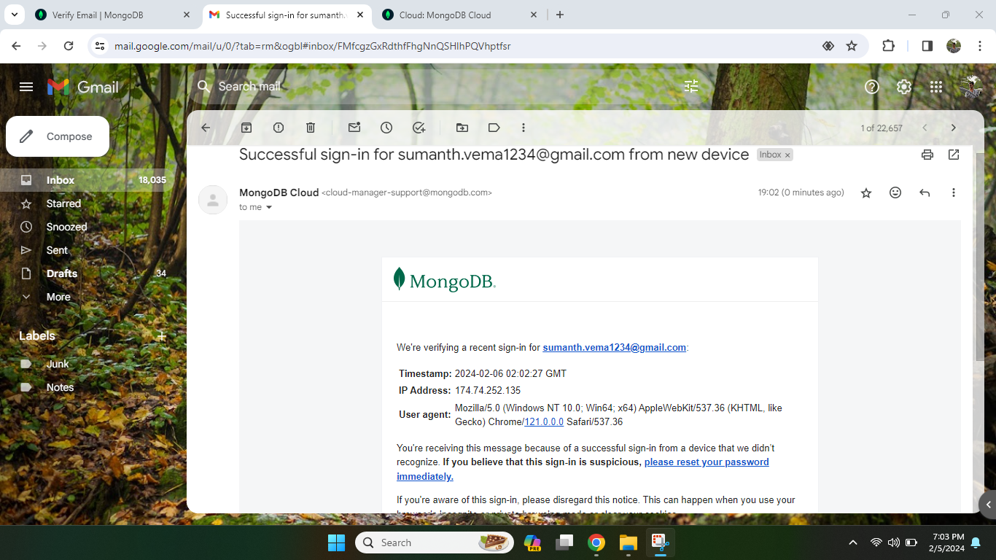

Screenshot 2: of the new project setup.

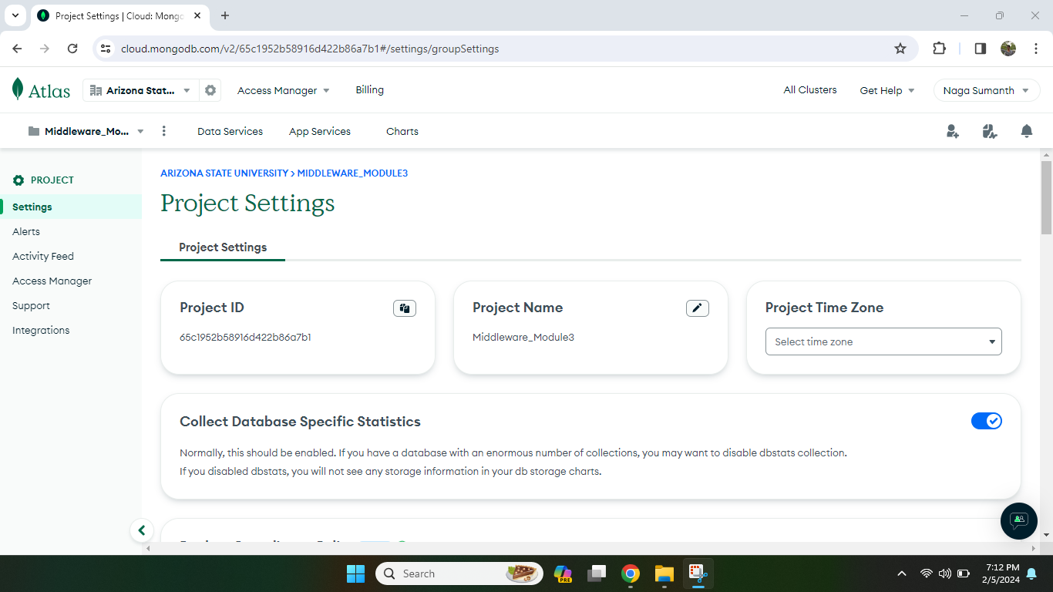

Screenshot 3: of the new cluster in MongoDB Atlas.

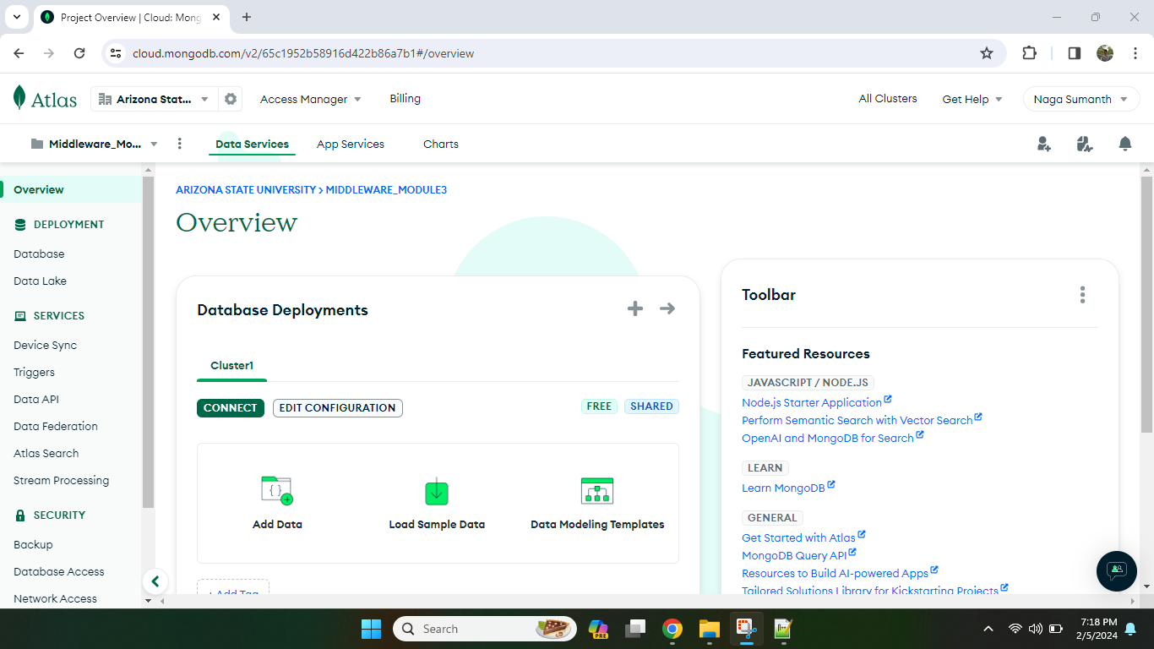

Screenshot 4: of the database and collections (the student can blur or hide sensitive data).

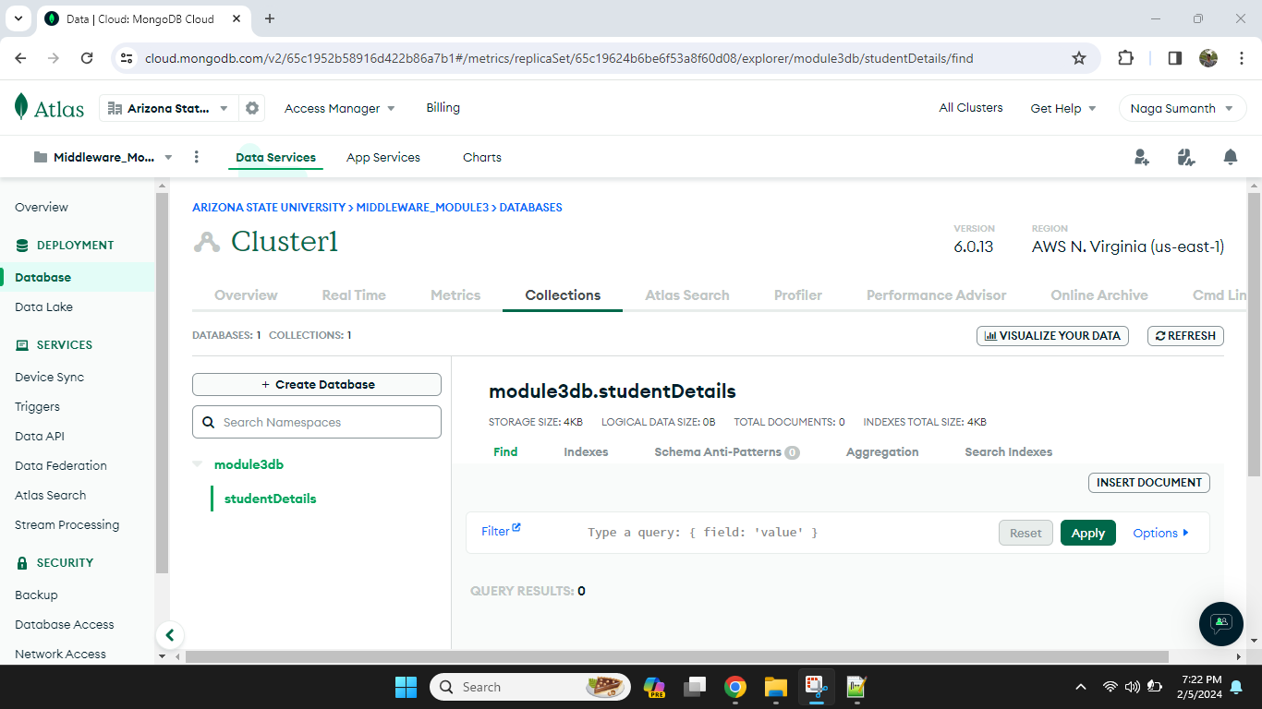

Screenshot 5: of the connection IP and user setup. I have blurred my ip address and username with snip tool sketch.

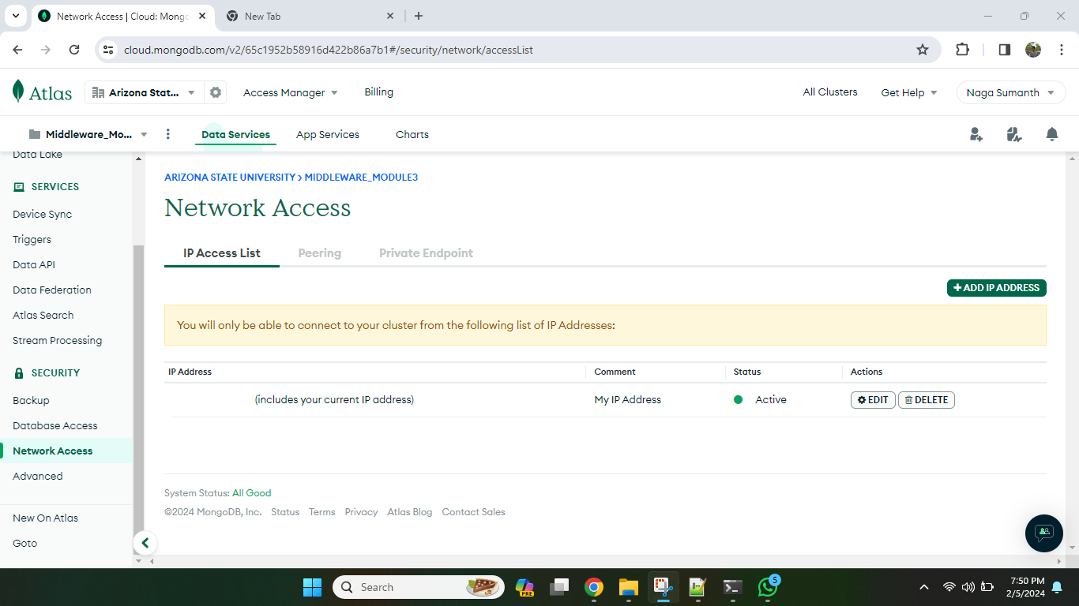

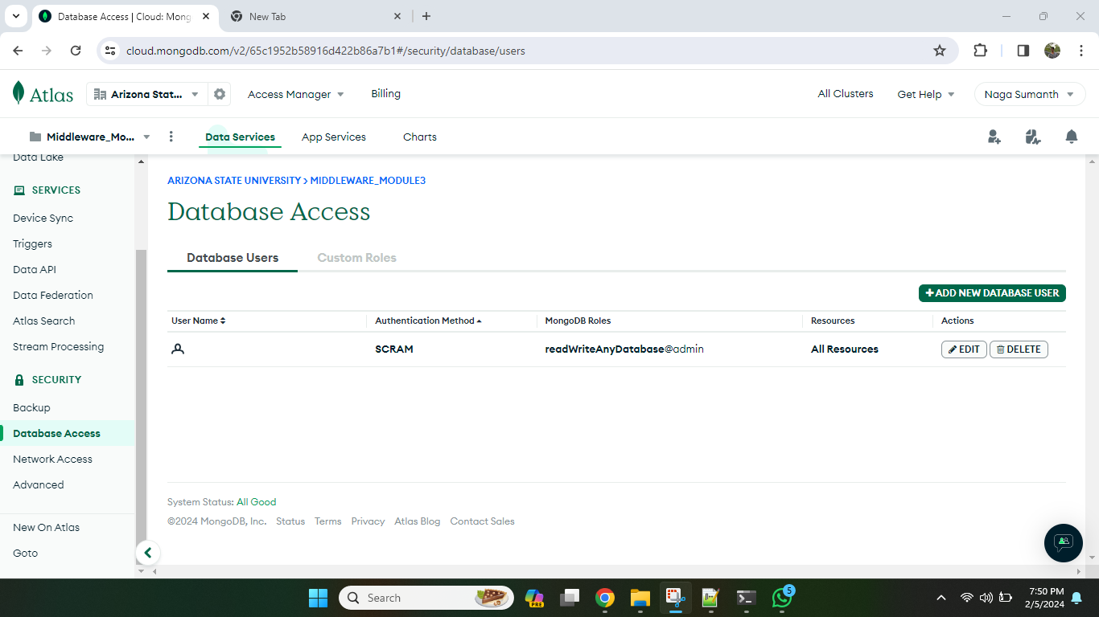

Screenshot 6: of the connection string (the student should blur out sensitive parts like username and password).

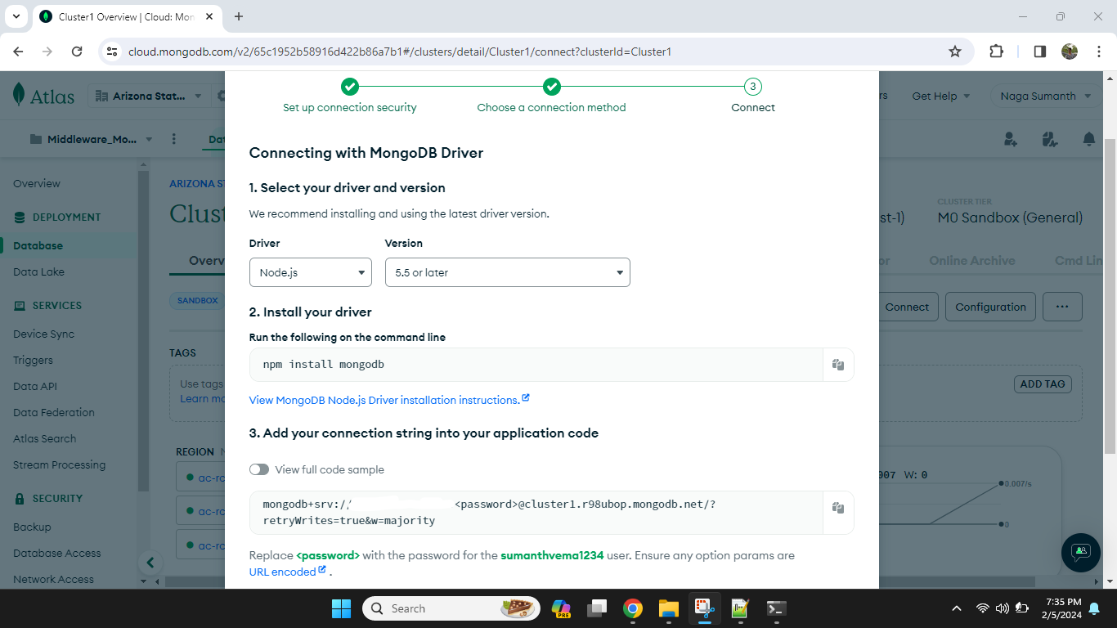

Optional Screenshot showing code and npm install mongoose command in terminal:

